Utah Division of Water Quality’s Tiered Framework
To integrate the various programmatic data needs within the division, DWQ employs an adaptive approach to its annual monitoring plans, which allows for an efficient and adaptive monitoring and management program.
This tiered adaptive monitoring and management framework for DWQ allows the division to develop robust datasets in Year 1 that inform the data collection and assessment decision making in subsequent years (Figure 1-3). In this adaptive program, monitoring continues to iteratively improve the knowledgebase of management, so decision making is based on the best science available. As more information becomes available, the scientific uncertainty about the ecosystem is reduced, and initial actions and management decisions are revisited and refined (see Figure 1-3). During the evaluation process at DWQ, the information that is gathered provides staff with critical input on how to adjust to the next round of monitoring in the three types of monitoring and assessment efforts described below.
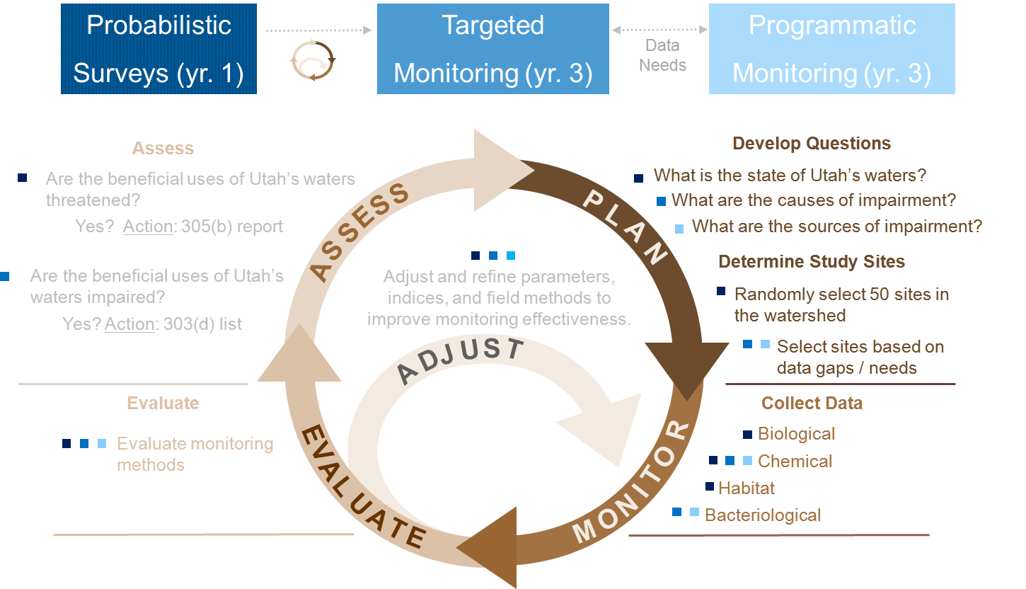
Figure 1-3. DWQ’s adaptive monitoring approach.
- Probabilistic Surveys: Designed to meet the reporting requirements of the 305(b), probabilistic surveys assess all waters of the state by randomly selecting and monitoring different waterbodies within one of the seven major watersheds in Utah (see Table 1-2 for the proposed rotating basin schedule over the next 8 years). The information collected from the environmental surveys is used to 1) assess the attainment of various designated uses (e.g., aquatic life and contact recreational uses) and 2) better understand the significant causes of pollution throughout Utah.
- Targeted Monitoring: Environmental surveys within this monitoring effort are performed annually to develop the 303(d) impairment status reports. Using the water quality concerns that are highlighted during probabilistic surveys as a guide, site-specific monitoring plans during targeted monitoring efforts are used to assess the biological and chemical conditions of a specific stream (see Figure 1-3). These more intensive surveys allow DWQ to more fully understand the scope and extent of water quality problems in the state.
- Programmatic Monitoring: Surveys within this monitoring effort are performed annually, alongside targeted monitoring efforts. This is done to maximize division resources in the targeted watershed. During these programmatic monitoring efforts, the data needs of the division are met; these needs include TMDL development, evaluation of nonpoint source (NPS) project effectiveness, development or refinement of numeric water quality criteria, and a variety of compliance monitoring programs.

Rotating Basin Schedule
To implement the monitoring and assessment efforts described above, DWQ developed a 6-year rotating basin monitoring schedule to ensure that 1) staff has sufficient data to determine if a waterbody is impaired and 2) DWQ can work toward its goal of assessing all 12,000 miles of wadeable rivers and streams and 137 lakes and reservoirs in the state.
By focusing the division’s monitoring efforts on a couple of river basins each year (versus the whole state), DWQ is able to concentrate its monitoring efforts on a smaller geographical area and collect more water quality samples from numerous waterbodies within a watershed management unit during a single sampling season. Using this rotating sampling structure allows DWQ staff to make more accurate assessments and informed 303(d) listing decisions by having a more robust dataset to work with.

Table 1-2. Summary of DWQ's 6-year rotating basin monitoring schedule.
Watershed  Management  Unit | YEAR
 | 2009 |  | 2010 |  | 2011 |  | 2012 |  | 2013 |  | 2014 |  | 2015 |  | 2016
Jordan-Utah Lake
Colorado
Sevier, Cedar, Beaver
Great Salt Lake, W. Desert
Bear River
Weber River
Uinta Basin
 | Targeted |  |  |  |  |  |  |  | Probabilistic

Integrating the proposed tiered monitoring framework into current division and programmatic needs and constraints requires targeted and programmatic monitoring efforts to follow the probabilistic surveys (1–2 years later) and focus on ongoing TMDL needs around the state until the initial round of probabilistic surveys is assessed.

